**TASK 1**

**Objective: Programming**

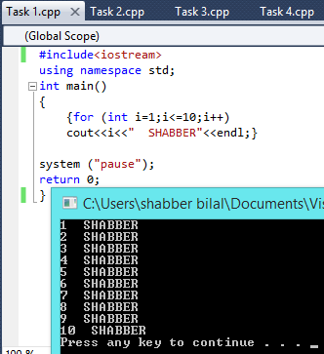

Write a C++ Program that print your name 10 times.

**TASK 2**

**Objective: Programming**

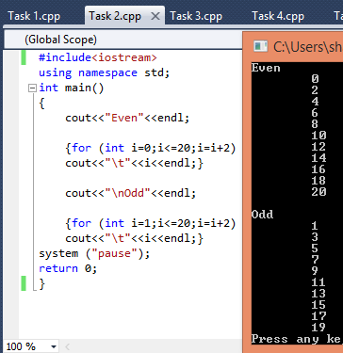

Write a C++ Program that prints even and odd numbers from 1 to 20

**TASK 3**

**Objective: Programming**

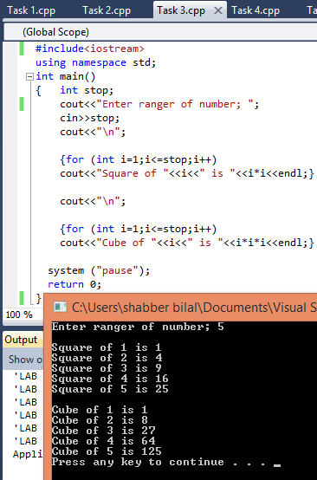

Write a C++ Program that takes value as input and prints square and cube of numbers till value entered by user.

**TASK 4**

**Objective: Programming**

Write a program that takes number and range as input and print the table of that number upto the range entered by user.

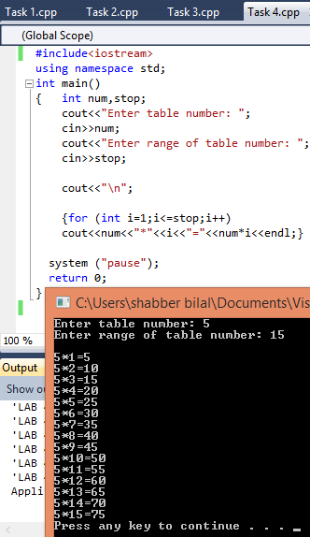

**TASK 5**

**Objective:**

Write a C++ Program that takes number as input from user and print factorial of that number.Use for and while loops.

**FOR LOOP Programming**

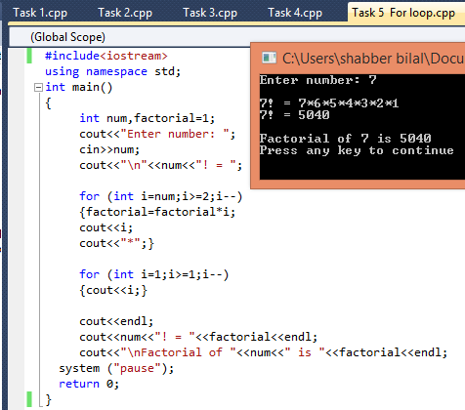

**WHILE LOOP Programming**

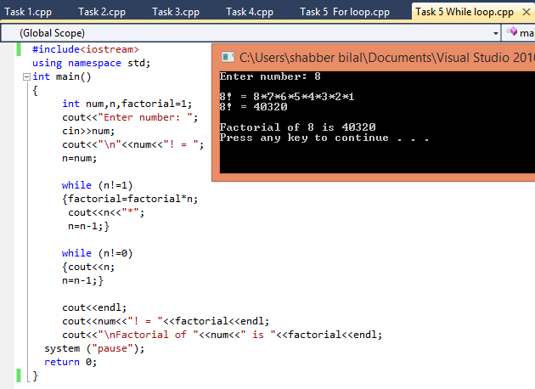

**TASK 6**

**Objective:** **Programming**

Write a program that characters as input until user enters ‘k’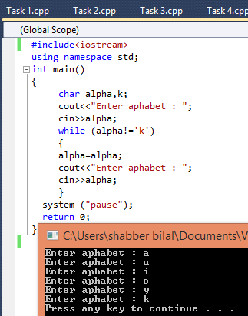

**TASK 7**

**Objective:**

Write a C++ Program that displays a series of alphabets in ascending order from ‘A’ to ‘Z’.

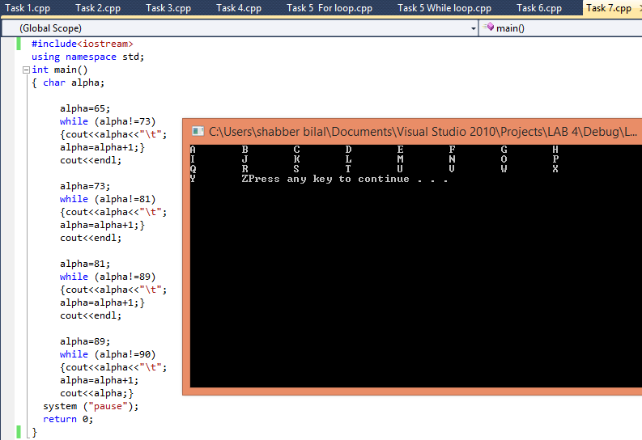**Programming**

**TASK 8**

**Objective:**

Modify your program in task 7 so that the program will display consonants only, not vowels.

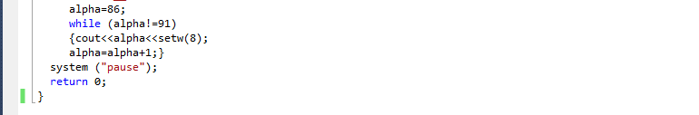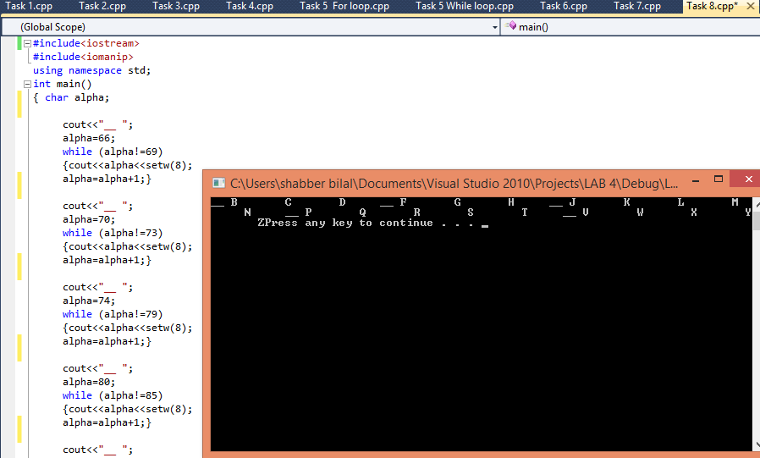**Programming**